Predicting house prices using machine learning involves creating a model that can estimate the selling price of a house based on various features or attributes. Here's a basic problem definition:

Problem Statement:Develop a machine learning model that can predict the selling price of a house given a set of input features such as square footage, number of bedrooms, location, etc.

Key Steps:

1. Data Collection:Gather a dataset that includes historical information about houses, including both features (e.g., size, location, number of rooms) and their actual selling prices.

2. Data Preprocessing: Clean and preprocess the data by handling missing values, encoding categorical variables, and scaling numerical features.

3. Feature Selection/Engineering:Select relevant features and possibly create new features that can improve the model's predictive performance.

4. Model Selection: Choose an appropriate machine learning algorithm for regression tasks. Common choices include linear regression, decision trees, random forests, and neural networks.

5. Splitting Data:Divide the dataset into a training set and a test set to evaluate the model's performance.

6. Model Training: Train the selected machine learning model on the training data.

7. Model Evaluation:Evaluate the model's performance using appropriate metrics like Mean Absolute Error (MAE), Mean Squared Error (MSE), or Root Mean Squared Error (RMSE).

8. Hyperparameter Tuning: Fine-tune the model's hyperparameters to optimize its performance.

9. Model Deployment: Once satisfied with the model's performance, deploy it for real-world predictions.

10. Monitoring and Maintenance:Continuously monitor the model's performance and update it as needed to ensure accurate predictions over time.

This problem is commonly referred to as a regression problem, and there are various machine learning libraries and frameworks available (e.g., scikit-learn, TensorFlow, PyTorch) that can help you implement this solution. Remember that the quality and quantity of your data, as well as feature selection and engineering, play crucial roles in the success of your model.

Design thinking is a human-centered approach to problem-solving that can be applied to the task of predicting house prices using machine learning. Here’s a design thinking approach to tackle this problem:

1. Empathize:Understand the needs and pain points of potential users of the house price prediction model. This could include homebuyers, sellers, real estate agents, or investors. Conduct interviews, surveys, or observations to gather insights.
2. Define:Clearly define the problem you are solving. For example, is it about helping buyers make informed decisions, assisting sellers in pricing their properties accurately, or aiding real estate professionals in market analysis?
3. Ideate:Brainstorm potential features and data sources that could be valuable for predicting house prices. Consider both traditional features like square footage and bedrooms as well as non-traditional data like neighborhood sentiment analysis or local economic indicators.
4. Prototype: Create a basic prototype or mockup of the model’s interface or user interaction. This could be a simple web app or a visualization tool that demonstrates how the model will work.
5. Test:Gather feedback on your prototype from potential users or stakeholders. Determine if the features and data used by the model align with the needs and expectations of the users.
6. Collect Data: Acquire a relevant dataset for training and testing the machine learning model. Ensure the data is representative of the problem and is cleaned and preprocessed appropriately.
7. Model Development:Select and implement machine learning algorithms and techniques suitable for regression. Experiment with different models, feature engineering, and hyperparameter tuning.
8. Evaluate: Assess the model’s performance using appropriate evaluation metrics. This might include Mean Absolute Error (MAE), Mean Squared Error (MSE), or others.
9. Refine: Iterate on the model and its features based on user feedback and evaluation results. Make improvements to enhance accuracy and usability.
10. Deploy: Once satisfied with the model’s performance, deploy it as a user-friendly tool or application. Ensure it’s accessible to the target audience, whether through a website, mobile app, or other means.
11. Feedback Loop:Establish a mechanism for continuous feedback from users. Monitor the model’s predictions in real-world scenarios and update it as needed to adapt to changing market conditions.
12. Scale: If the model proves successful, consider scaling its usage to a wider audience or expanding its capabilities to cover additional geographic regions or property types.

Throughout this process, it’s essential to keep the end-users’ needs and preferences at the forefront, as design thinking encourages a user-centric approach to problem-solving. Additionally, collaboration among cross-functional teams, including data scientists, designers, and domain experts, can lead to a more holistic and effective solution.

Idea: Create a predictive model that incorporates an Environmental Impact Index (EII) to estimate house prices. This model takes into account the ecological sustainability of the property’s location, in addition to traditional factors like square footage, number of bedrooms, and neighborhood.

Components:

1. Environmental Data Integration: Collect data on the environmental impact of the property’s location, including factors like air quality, proximity to green spaces, energy efficiency, and more. This data can be obtained from government sources, environmental agencies, and satellite imagery.
2. Machine Learning Model: Use a machine learning algorithm, such as a gradient boosting ensemble, to build the predictive model. It should consider traditional features (e.g., property size, number of bedrooms) along with the EII data.
3. Feature Engineering: Create features that quantify the environmental impact of the property’s location. For example, an index that rates the air quality, availability of public transportation, and access to renewable energy sources.
4. Data Normalization: Normalize both traditional and EII features to ensure they contribute equally to the model.

5.Training and Testing: Train the model on historical housing data with known prices and corresponding EII values. Use cross-validation techniques to assess the model’s performance.

6.Scalability: Ensure the model can scale for different regions and cities by collecting EII data specific to each area.

7.User Interface: Develop a user-friendly interface or app that allows potential buyers and sellers to input property information and receive a price estimate based on the predictive model.

Benifits:

1.Eco-friendly Property Assessment: Buyers can make more environmentally conscious choices when purchasing properties.

2.Increased Transparency: Sellers can justify asking prices by including EII data, making the real estate market more transparent.

3.Market Resilience: This approach can contribute to more resilient real estate markets by considering long-term environmental sustainability.

4.Government Incentives: Encourage governments to provide incentives for properties with high EII ratings, promoting sustainability.

Remember that building such a model requires access to comprehensive data, expertise in machine learning, and collaboration with environmental agencies. It can help potential buyers and sellers make informed decisions while promoting environmentally responsible practices in the real estate market.

INTRODUCTION:

This document outlines the preprocessing steps undertaken to prepare a comprehensive dataset for the task of house price prediction using machine learning. The dataset may be derived from various sources, and this document provides a detailed description of the data integration and preprocessing procedures.

DATA SOURCES:

The dataset comprises information from various sources, which may include real estate listings, property records, or other relevant data sources.

DATA INTEGRATION:

The initial step involves importing data from each source using the Pandas library in Python. The data files are read and stored in separate DataFrames. These DataFrames are then merged horizontally (column-wise) to create a consolidated dataset, ensuring that duplicate columns are removed to avoid redundancy.

DATA PREPROCESSING:

The preprocessing of the dataset involves several essential tasks, similar to those outlined in your previous document for energy consumption:

1. HANDLING MISSING VALUES:

- Address missing values using techniques such as interpolation, forward-fill, or backward-fill to ensure a complete dataset.

2. FEATURE ENGINEERING:

- Create additional features to enhance the dataset’s predictive power. This may include transformations, scaling, or the creation of new derived features.

3. DATA TYPE CONVERSION:

- Check and modify data types to ensure consistency. In particular, non-numeric data types should be converted to numerical types to make them compatible with machine learning algorithms.

PROGRAM:

Import pandas as pd

Import matplotlib.pyplot as plt

Import seaborn as sns

Dataset = pd.read_excel(“HousePricePrediction.xlsx”)

# Printing first 5 records of the dataset

Print(dataset.head(5))

Dataset.shape

RESULT:

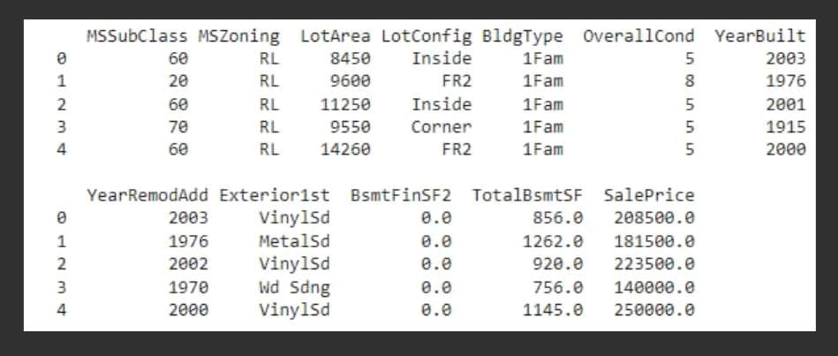

CONCLUSION:

The successful preprocessing of the dataset is a critical step in any machine learning project, including house price prediction. By combining data from multiple sources and ensuring data quality, you have created a solid foundation for future research and modeling in the domain of predicting house prices.

**DEVELOPMENT**:

Introduction:

In the pursuit of accurate house price predictions, feature selection, model training, and evaluation stand as pivotal stages. Feature selection trims away noise, while model training harnesses algorithms for insights. Evaluation metrics like MAE, MSE, RMSE, and R2 are crucial gauges of success.

Feature Selection:

Feature selection is a critical step to improve the model’s performance and reduce complexity. Here are some methods you can consider:

1. Correlation Analysis: Calculate the correlation between features and the target variable (house prices). Select features with high correlation.

2. Feature Importance: If you’re using tree-based models (e.g., Random Forest or XGBoost), you can extract feature importance scores and select the most important features.

3. Recursive Feature Elimination: Use techniques like Recursive Feature Elimination (RFE) to iteratively remove less important features.

Model Training:

Choose the machine learning algorithms you want to use for your house price prediction. Common choices include Linear Regression, Random Forest, XGBoost, and Support Vector Machines. Here’s a basic outline for model training:

1. Split the Data: Divide your dataset into training and testing sets to evaluate the model’s performance.

2. Feature Scaling: Standardize or normalize your features, especially if you’re using algorithms sensitive to feature scales.

3. Train the Models: Train different models using the training data. Tune hyperparameters to optimize model performance.

Evaluation:

Evaluating your model’s performance is crucial to ensure it makes accurate predictions. Common evaluation metrics for regression tasks (like house price prediction) include:

1. Mean Absolute Error (MAE): Measures the average absolute difference between the predicted prices and the actual prices.

2. Mean Squared Error (MSE):Measures the average of the squared differences between predicted and actual prices.

3. Root Mean Squared Error (RMSE): The square root of MSE, which gives you an error metric in the same unit as the target variable.

4. R-squared (R2):Indicates the proportion of the variance in the dependent variable (house prices) that’s predictable from the independent variables (features).

5. Cross-Validation: Perform cross-validation to assess the model’s generalization performance.

6. Visualization: Use plots like scatter plots to visualize the actual vs. Predicted prices

Program:

# Feature Selection

# Example: Using correlation analysis to select relevant features

Correlation_matrix = dataset.corr()

Correlation_with_target = correlation_matrix[‘HousePrice’] # Assuming ‘HousePrice’ is your target variable

Relevant_features = correlation_with_target[abs(correlation_with_target) > 0.2].index.tolist()

Selected_data = dataset[relevant_features]

# Model Training

From sklearn.model_selection import train_test_split

From sklearn.linear_model import LinearRegression

# Split the data into training and testing sets

X = selected_data.drop(‘HousePrice’, axis=1)

Y = selected_data[‘HousePrice’]

X_train, X_test, y_train, y_test = train_test_split(X, y, test_size=0.2, random_state=42)

# Train a linear regression model

Model = LinearRegression()

Model.fit(X_train, y_train)

# Evaluation

From sklearn.metrics import mean_squared_error, r2_score

# Make predictions

Y_pred = model.predict(X_test)

# Calculate evaluation metrics

Mse = mean_squared_error(y_test, y_pred)

R2 = r2_score(y_test, y_pred)

# Print the results

Print(f”Mean Squared Error: {mse}”)

Print(f”R-squared (R2): {r2}”)

This code provides a basic example of feature selection, model training using Linear Regression, and evaluation using Mean Squared Error (MSE) and R-squared (R2) as metrics.

Conclusion:

Feature selection, model training, and evaluation form the core of effective house price prediction. These steps ensure that our models are robust and precise, empowering us to make informed decisions in the dynamic world of real estate.